SOCIETY FOR INTEGRATED DEVELOPMENT AND RESEARCH (SIDAR)

Dr. L. Bullayya College Premises, Block No. 9, Visakhapatnam-13

(Established on 24th March 2018 – No. 201 of 2018)

1st Annual Report 2018-19

The SIDAR has been functioning since its establishment in tune with its mandate. They are broadly divided into training related, in-house discussions pertaining to contemporary issues, and research on socially relevant aspects. A detailed statement of these programmes is presented hereunder:

- Workshop for UG College Teachers

SIDAR conducted a Four Day- Workshop during 11-14 June 2018 for Under Graduate College Teachers working in Dr. L.B. College and PRISM College of Visakhapatnam City. Teachers from different subjects have participated. Eminent teacher trainers and educationists delivered lectures on varied topics. The prominent among them are Dr. B.V. Mohan Reddy, Former Chairman, NESCOM and Executive Chairman, CYIENT, Hyderabad; Professor R. Venkata Rao, Vice-Chancellor, National Law School of India University, Bangalore; Professor A. Prasanna Kumar, Director, Centre for Policy Studies, Visakhapatnam; Professor P. Jayaprakash Rao, Former Chairman, AP State Council of Higher Education, Hyderabad; Sri C. Anjaneya Reddy, Chairman, Hyderabad Study Circle and Professor V. Balamohan Das, Former Vice Chancellor, Acharya Nagarjuna University, Guntur. Several local resource persons shared their experiences in Teaching-Learning processes.

The feedback of the participants is both positive and encouraging. Therefore SIDAR is planning to enhance teaching-learning outcomes and skills organising more such programmes. The event coverage is posted on SIDAR Website with news cuttings and photographs.

- Brainstorming Session on SIDAR-Way Forward (25th July 2018)

The session was chaired by Prof Raj Reddy and moderated by Prof KC Reddy. The lead discussants are Prof A Prasanna Kumar, Prof KV Ramana, Sri C Anjaneya Reddy, , Sri V Bhaktavathsalam, Dr K Lakshminarayana, Prof VSRK Prasad, Dr M Malakondaiah, Sri Venkateswara Rao, Sri Himakar Tata, Prof V Balamohan Das, Sri Venu and Ms Lakshmi. They expressed their experiences with several case studies, anecdotes, and suggested issues to be handled by SIDAR in its future endeavours. They suggested to focus on local issues like environment and human development. The event coverage is posted on SIDAR Website with news cuttings and photographs. The PPT of the lecture is also uploaded.

First Foundation Lecture of SIDAR (25th July 2018)
A lecture meeting was held in AU Campus, presided by Prof. K.C.Reddy and Prof.Raj Reddy from Carnegie Mellon University delivered the lecture. It was attended by several academics, elite of the city and students. The SIDAR website with id www.sidarindia.org was formally launched by Professor Raj Reddy, and soon after he announced donation of a Digital Library to SIDAR as goodwill gesture and presented tablets to the office bearers as a token of proposed library. He was felicitated by the members of SIDAR Advisory Council (AC), Governing Council (GC) along with elite of the city. The event coverage is posted on SIDAR Website with news cuttings and photographs. The PPT of the lecture is also uploaded.

- Roundtable on “Higher Education Commission of India (Repeal of UGC Act) Act-2018”

SIDAR conducted Roundtable on “Higher Education Commission of India (HECI) (Repeal of University Grants Commission Act) Act 2018” on 5 th July 2018 in collaboration with Centre for Policy Studies (CPS) in Visakhapatnam Public Library. Several eminent educationists (professors of various fields of knowledge), education administrators (Vice-Chancellors), and education promoters (Colleges Managements) have participated and discussed at length on pros and cons of new Act. The need for and the importance of reforming Higher Education because of emerging challenges in technology and global competitiveness, along with exploiting India’s demographic dividend, has been a matter of discussion and debate for a while. Government of India’s current exercise to repeal UGC Act by introducing Higher Education Commission of India as a part of reforming higher education though considered necessary, the present Bill is neither holistic nor comprehensive. However, the group felt that without proper deliberations and feedback from the stake holders across the country, particularly when the bill aims at some significant changes in both governance and financial management of Higher Education, it is likely to end up as a non-starter. A key conclusion by the group was to consider reforming the UGC, instead of rushing the Bill without wider consultations and deliberations (as was done in the past when changes into education system were proposed). A list of prominent people who participated in the deliberations along with names of those who have sent their written views as they could not attend the round table is appended in the report. The discussion outcomes were consolidated into suggestions and forwarded to Ministry of HRD, Government of India portal, and the same is posted on SIDAR website.

Discussion Meeting on Establishment of an Institute of Social Sciences

A meeting to discuss the need for and desirability of an Institute of Social Sciences was convened at 11.00 A.M. on November 13, 2018 in the Dr.L.Bullayya College Campus. Several distinguished academics including former Vice-Chancellors and former Civil Servants who made significant contributions for research and training in social sciences and related areas have participated in deliberations. The meeting was chaired by Prof.K.V.Ramana, senior-most Social Scientist of Vizag and Former Vice-Chancellor of Andhra University. SIDAR prepared background note in consultation with Prof.A.Prasanna Kumar, Shri C.Anjaneya Reddy and Prof.Bhanoji Rao. Secretary of the SIDAR made a power point presentation prepared on the basis of background.
There was consensus on the need for a centre for social sciences, particularly in Visakhapatnam considering the rich intellectual wealth available in the city. It was also agreed that the proposed Institute may be called as “Visakha Institute of Social Sciences (VISS)”. The distinguished participants felt that the proposed institute need to become a centre of excellence both in teaching and research offering only multi-dimensional 5-year integrated course with a flexibility and a provision for early exit for those who want an under-graduate degree. Members also felt that it should be autonomous, academically, administratively and financially and therefore creating a good corpus is a basic prerequisite. It was also cautioned that the proposed institute must take into consideration the successful and other similar programmes being offered within India to evolve an institute that will cater to the needs of not only of the Region but for the entire country. Further the meeting resolved to meet again for a more detailed discussion on the concept, structure, and the mandate for the proposed institute. The proposal note, power point presentation and photographs of the event are posted on SIDAR Website. A detailed note on discussions is being posted soon.

Discussion Meeting on Way Forward of Visakha Institute of Social Sciences (VISS)

A second round of discussion was held at 11.00 A.M. on Monday, the 18th February 2019 at Dr.L.Bullayya College Campus to discuss on the need for and desirability of an Institute of Social Sciences in Visakhapatnam. A number of distinguished academics including former Vice-Chancellors and former Civil Servants who made significant contributions for research and training in social sciences and related areas have participated. SIDAR prepared a concept note in consultation with Shri C.Anjaneya Reddy, I.P.S.(Rtd.). Prof.K.C.Reddy, President, SIDAR, made a brief presentation on the key aspects.

The meeting resolved unanimously to set up the proposed Institute which functions autonomously and will be named as “Visakha Institute of Social Sciences (VISS)”. The institution will focus on research initially and it will involve in strengthening programmes offered in Dr.L.Bullayya College. The proposal for the Institute will be prepared and submitted for approval of the new government soon after it is formed in the State. Later, it will be taken to ICSSR for recognition. SIDAR and Society for Collegiate Education will both sponsor the institution and it will be housed in Dr.L.Bullayya College premises till it gets own campus. The institute will seek funding from both public and private sources with one time grant from State Government.

- Digital Library

As scheduled the DIGITAL LIBRARY of SIDAR-DrLBC Knowledge Resource Centre is inaugurated on 11th December 2018 at 12.00 noon by Professor Rokkam Radhakrishna, a distinguished Social Scientist, Chairman-CESS and Former Vice Chancellor, Andhra University. It was well attended by eminent scholars and faculty of Dr.L. Bullayya College. Prof. Radhakrishna spoke about the importance of digital library in the contemporary knowledge society, and pointed out the distinction between knowledge and wisdom. While referring to digital information and its strength to extend wisdom he quoted European examples. He congratulated the hosting institutions, SIDAR and DrLBC, which have provided a scientific platform for the users to convert into knowledge people by citing the China and India before digitization and a need to compete with Chinese digital literacy. He also cautioned the necessary steps to develop content, categorization and its accessibility to students, faculty and citizens for better use of the facility.

While talking on the event Professor K.C. Reddy, President of SIDAR and Society of Collegiate Education, Dr.L.B.C, mentioned that the whole idea of having a digital library was mooted by Professor Raj Reddy, the then Chancellor, RGUKT, who magnanimously donated tablets and provided free access to World Digital Library. Now the Digital Library is one of its kind in the city of Visakhapatnam with 40 user terminals accessed through tablets. The interested users may access the website get registered and make use of the facility. We are planning to develop the content as suggested by subject experts and in accordance with the feedback from the users.

- Meeting of SIDAR Environment Group:

A couple of discussion meetings were held in SIDAR Office to discuss research proposals on Visakhapatnam City. Prof. Krishna Prasad, the Team Leader has appraised the SIDAR Group on Environment, particularly on Air and Water resources and related quantitative data available at various sources. The members have discussed on several issues of probable working models on estimation of pollution. It is decided to form into two sub-groups, Air and Water. Sub-Group on AIR: Dr. G.Ganga Raju, Dr. K. Satti Reddy and Dr. Kiran Kumari (Nominated afresh). Sub-Group on Water: Ms. B. Madhavi, , Ms. R. Sridevi and Mr. Harish Babu, while Ms. V. Sailaja will work on PYTHON language to generate scientific models by using AI.

- Lecture Meeting on “Social Entrepreneurship-Challenges” (15th March 2019)

A Public Lecture on “Social Entrepreneurship – Challenges” was organised by the SIDAR in association with Dr. L. B. College and Centre for Policy Studies in the Seminar Hall, Dr.L.B. College, Visakhapatnam. Many distinguished participants have attended the lecture. Dr. K.I. Varaprasad Reddy, Founder Chairman, Shanta Biotechnics, Hyderabad, had delivered the lecture. He emphasised the importance of social entrepreneurship, and the need of the society and then working on the demand and supply ratio. He reiterated why he founded Shantha Biomechanics, and how he took the participants on walk down the memory lane three decades ago. He said that despite being an electronic engineer, he delved into the path of biotechnology, as India was ridiculed for being poor and not being able to produce a Hepatitis-B vaccination. He gave a glimpse of his travails in setting up a research lab in Osmania University and the Centre for Cellular and Molecular Biology, Hyderabad until an independent Research and Development facility was built by him.

He said “On one hand we did not have the technology, facility, experience and finance and on the other we had the government red-tapism in issuance of licences. Thereafter, every step was a challenge right from preclinical trials to convincing the animal rights and human rights groups. But I was firm in developing a vaccine that would be available for the poor”. In those days importing three doses of vaccine for two children in a family would cost around Rs.10,000 and he wanted to give it to the people for Rs. 50/- and could succeed to deliver the vaccine after a struggle for almost six years. He also mentioned that prior to the development of the vaccine, about 45 million children were infected. He opined that India is lagging behind in R & D. He said that while Pfizer, a pharma company, was spending around $4.7 billion on R & D, our country’s budget is just $3 million. He expressed that also the present system of education has become more academic in nature and has lost the touch of values.

- Meetings of MBA Faculty and Students on Urban Amenities of Visakhapatnam City

Several rounds of meetings are being conducted in batches with faculty and as well as students and to discuss at length several issues of civic amenities and the need for developing a database for further research and monitoring policy intervention. Since this proposed task is unique and innovative prolonged scientific discussions are being in the process. At the moment, topics of academic and society related are being finalised for inquiry during the forthcoming summer vacation of 2019. (See Appendix)

OTHER ISSUES:

- Appointments (Manpower):

In addition to an Office Assistant (Mr.K.Sunil Kumar) and an Office Boy (Mr.K.Deva), whose services are being rendered by Dr. L.B. College Management, the SIDAR had appointed one Office Assistant (Mr.JSS Gopala Krishna) on 1st September 2018 and a Research Associate (Dr. G. Pavan Kumar) on 6th September 2018 with support from PRISM.

- Appointments (Income Tax):

The firm of M/s.Jaya & Lakshmi, Chartered Accountants, 49-56-2, Vidyut Nagar, Visakhapatnam-24 may be appointed as Auditors for the SIDAR for three years. The firm has been helping SIDAR since inception on maintaining accounts.

- Income Tax Exemption:

SIDAR has been pursuing to obtain Income Tax exemption under Section 80G (5) VI of the Income-Tax Act, 1961. Two levels of verification are over. Expecting positive orders soon.

- Statement of Accounts:

The Income and Expenditure Statements of Accounts for the Years 2017-18 and 2018-19 are being audited. However, an unaudited statement of income and expenditure is presented to the members once received from the auditors.

UNAUDITED STATEMENT OF INCOME AND EXPENDITURE FOR THE YEAR 2017-18

- - - - - - - - - - - -- - - - - - - - - - - - - - - - - - - - - - - - - - - - - - - - - - - - - - - - - - - - - - - - - - -- - - - - - - - - - - - --------
INCOME EXPENDITURE
- - - - - - - - - - - - - - - - - - - - - - - - - - - - - - - - - - - - - - - - - - - - - - - - - - - - - - - - - - - - - - - - - - - - - - - - - - - - --- - Rs. Rs.

Cash Deposit for opening Bank A/c : 3,000 Total Expenditure: 5,789

- - - - - - - - - - - - - - - - - - - - - - - - - - - - - - - - - - - - - - - - - - - - - - - - - - - - - - - - - - - - - - - - - - - - - - - - - - - - - - -

UNAUDITED STATEMENT OF INCOME AND EXPENDITURE FOR THE YEAR 2018-19
- - - - - - - - - - - -- - - - - - - - - - - - - - - - - - - - - - - - - - - - - - - - - - - - - - - - - - - - - - - - - - -- - - - - - - - - - - - - - - -
INCOME EXPENDITURE
- - - - - - - - - - - - - - - - - - - - - - - - - - - - - - - - - - - - - - - - - - - - - - - - - - - - - - - - - - - - - - - - - - - - - - - - - - - - - - - Rs. Rs.
B/F for the year 2017 - 18 ( - ) 5789

Membership Fee 22,05,000 Total Expenditure : 3,17,919

*Add: TDS on FDRs 4,233
------------- 3,22,152
Less: 3 FDRS @ Rs.5.0 lakhs 15,00,000
-------------- Bank balance ... 3,67,363
7,05,000
Cash on hand ... 3,550
*Add: Interest accrued 42,321 ------------- 3,70,913
on FDRs ------------------ -------------
7,47,321 6,98,854

- - - - - - - - - - - - - - - - - - - - - - - - - - - - - - - - - - - - - - - - - - - - - - - - - - - - - - - - - - - - - - - - - - - - - ------- - - - - -* As per Bank Statement. Not reflected in the Bank Passbook.

- Programmes for the year 2019-20:
a. Starting of Visakha Institute of Social Sciences
b. Taking up studies relevant to the region, state and country
c. Organization of motivational lecture programmes
d. Others suggested by the members.

- Any other item with the permission of the Chair:
-oOo-
Appendix-I

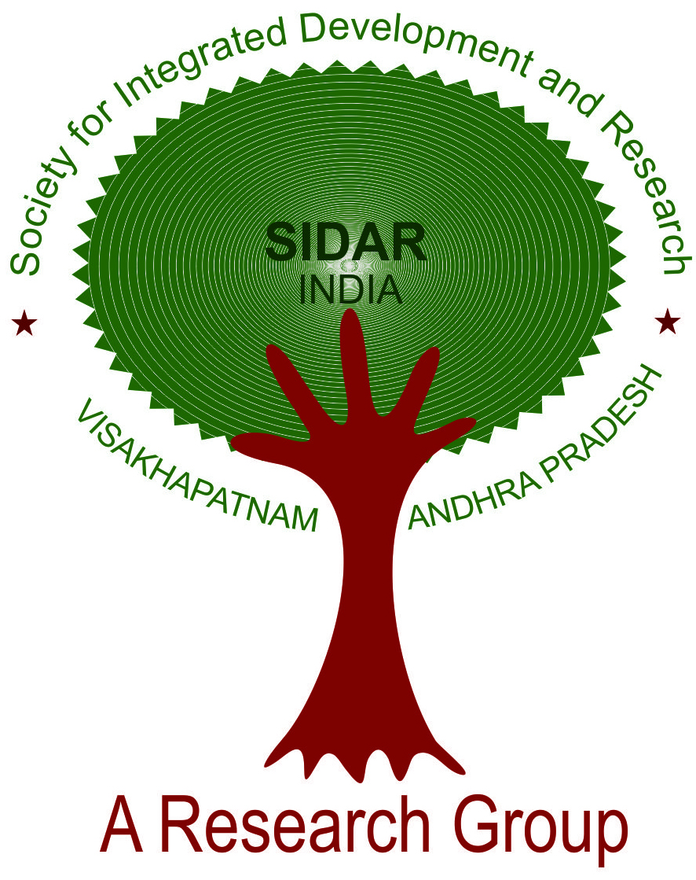
SOCIETY FOR INTEGRATED DEVELOPMENT AND RESEARCH (SIDAR)
# Dr.L.B. College Premises, Resapuvanipalem, VISAKHAPATNAM-530013
Registered No. 201/2018

Broad Topics of Research being conducted by MBA students under the guidance of Management
Faculty of Dr.L.B.C:

- Social Infrastructure:

- Schools and Education
- Public Libraries
- Demographic Trends
- Health and Hospitals
- Wastage Management

- Physical Infrastructure:

- Old Age Homes
- Corporate Social Responsibility
- Safety Services- Fire
- Rytu Bazaars
- Petty Traders/Street Traders

- Financial Schemes:

- Micro Finances (Daily/Weekly)
- Labour Supply and Wages

-oOo-

Appendix-II

SOCIETY FOR INTEGRATED DEVELOPMENT AND RESEARCH (SIDAR)
# Dr.L.B. College Premises, Resapuvanipalem, VISAKHAPATNAM-530013
Registered No. 201/2018

GOVERNING COUNCIL

S.No | Names | Designation | Contact No | Email IDs
01 | Prof. K.C. Reddy | President | 9848085975 | kalluricr@gmail.com
02 | Dr. G. Madhu Kumar | Vice-President | 8978773344 | gmadhukumar@gmail.com
03 | Prof. P. Vijaya Prakash | Secretary | 9849334310 | prakash.peethala@yahoo.com
04 | Sri D. S. Reddy | Joint Secretary | 9346454545 | maildsreddy@gmail.com
05 | Sri H.L.N. Dora | Treasurer | 9848529066 | hlndora1956@gmail.com
06 | Prof. V. Balamohandas | Member | 9848010187 | vbmdas@rediffmail.com
07 | Prof. G.S.N. Raju | Member | 9440777793 | profrajugsn@gmail.com
08 | Prof. G. Suryanarayana | Member | 9866317585 | sngollu@yahoo.co.in
09 | Prof. R. Sudarsan Rao | Member | 9441032865 | srrokkam@gmail.com
10 | Prof. A. Nageswara Rao | Member | 9848066460 | anipindinr@gmail.com
11 | Prof. T.V.V.S. Reddy | Member | 9440641545 | reddytvvs@reiffmail.com
12 | Prof. A. Padmavathi | Member | 9948498747 | padmavatiadari@gmail.com
13 | Sri P. Suryanarayana | Member | 9989133336 | pvenkanna9@gmail.com
14 | Sri J. Mallikarjunudu | Member | 9848191919 | jastibalaji@yaoo.com
15 | Dr. K. Satyanarayana | Member | 9441836198 | satyanarayana.kandukuri@gmail.com

Appendix-III

SOCIETY FOR INTEGRATED DEVELOPMENT AND RESEARCH (SIDAR)
# Dr.L.B. College Premises, Resapuvanipalem, VISAKHAPATNAM-530013
Registered No. 201/2018

GENERAL BODY:

1. Shri Anjaneya Reddy, C.
2. Prof. Balamohandas, V.
3. Shri Banoji Rao, V.V.
4. Prof. Chenchi Reddy, K.
5. Shri Dora, H.L.N.
6. Shri Himakar Tata
7. Dr. Madhu Kumar, G.
8. Prof. Padmavathi, A.
9. Shri Ratnakar Reddy, K.
10. Ms. Salma A Mehdi, SJT.
11. Dr. Satyanarayana, K.
12. Shri Satyanarayana Reddy, D.
13. Prof. Seetharami Reddy, T.V.V.
14. Shri Suryanarayana, P.
15. Prof. Vijaya Prakash, P.
16. Prof. Suryanarayana, G.
17. Shri Mallikarjunudu, J.
18. Prof. Nageswara Rao, A.
19. Sri Velagapudi Satish

Institutional Members

1. Dr.L.B.College, Visakhapatnam
2. PRISM College, Visakhapatnam
3. M/s Ramky Pharma City (India) Ltd, Visakhapatnam
4. M/s Southern Cylinders, Hyderabad

Appendix-IV
SOCIETY FOR INTEGRATED DEVELOPMENT AND RESEARCH (SIDAR)
# Dr.L.B. College Premises, Resapuvanipalem, VISAKHAPATNAM-530013
Registered No. 201/2018

ADVISORY COUNCIL

- Professor Raj Reddy, Chancellor, RGUKT, AP
- Prof. N. Balakrishnan, Former Associate Director, IIS, Bangalore
- Professor K.L. Krishna, Chairman, Madras School of Economics
- Professor R. Radhakrishna, Chairman, CESS, Hyderabad
- Sri Ajay Kallam, I.A.S., (Retd.) Former Chief Secretary, AP Government
- Sri C. Anjaneya Reddy, I.P.S., (Retd.) Chairman, Hyderabad Study Circle
- Sri M. Malakondaiah, I.P.S., Former DGP
- Sri V. Bhaktavathsalam, Former CMD, IREDA
- Sri B.V.R. Mohan Reddy, Executive Chairman, CYIENT
- Prof. A. Prasanna Kumar, Director, CPS
- Sri V. Sitaramaiah, Charted Accountant
- Sri S. Vijaya Kumar, Chairman, Vijaya Nirman Ltd., Visakhapatnam
- Prof. VSRK Prasad, Director, Institute of Petroleum
- Prof. V.V.Bhanoji Rao, Professor of NUS, Singapore
- Prof. K.Ramakrishna Rao, Former Vice-Chancellor, AU
- Prof. Y.C. Simhadri, Former Vice-Chancellor, ANU, AU, BHU and PU
- Prof. K.Thimma Reddy, Former Dean, CDC, AU and Srisailam Centre, PSTU

-oOo-

